Mohammad Ali jinnah University

NAME:MARIAKHALILI

ID:FA17-MSCS-0059

Design Pattern

Assignment 2

Singleton Absract Diagram:

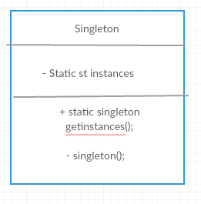

Factory Abstract Diagram:

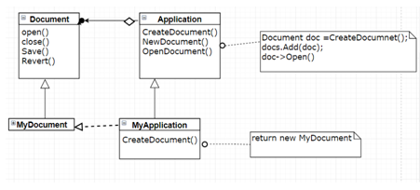

Decorative Abtract Diagram:

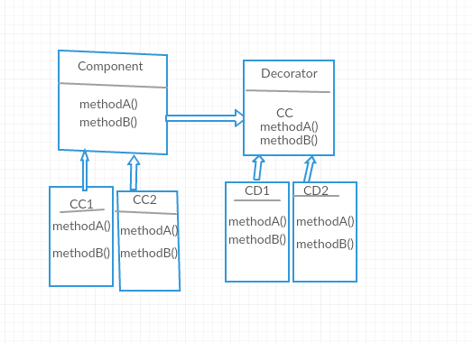

Adaptor Abstract Diagram:

